Prelab 5

5.1

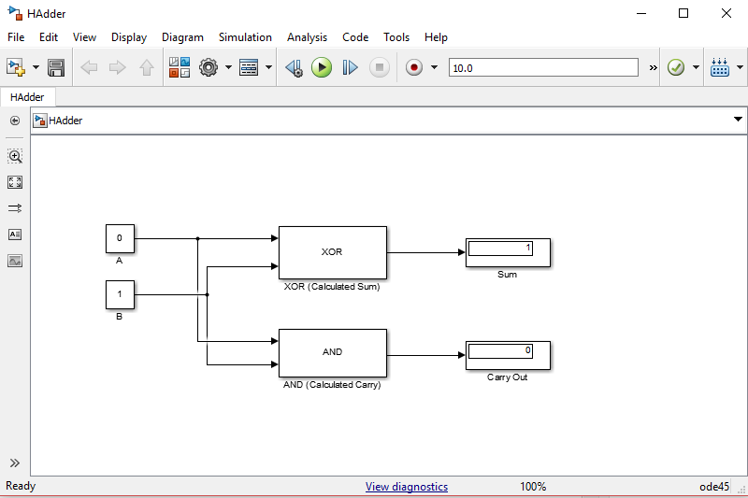

Add bit a and bit b, “Sum” is the sum of them, “Carry Out” is the carry out if the sum is greater or equal to 2.

5.2

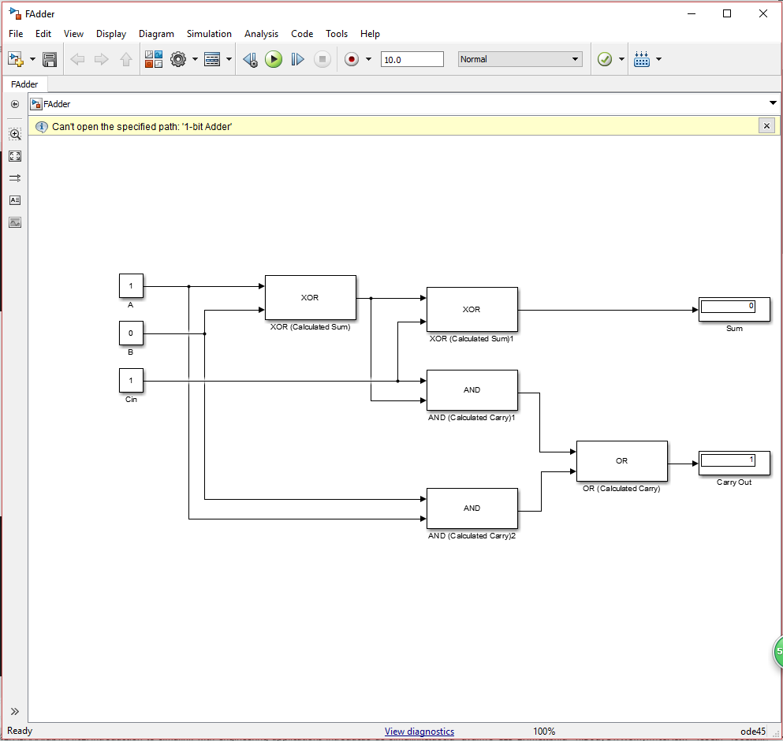

A B and bits used to add. Cin is the carry in bit. Sum them together to get Sum and carry out. The logic behind it is easy. If A, B and C only have one “1”, the sum is 1. If A, B and C have more than two “1”s, the carry out is 1. Otherwise, they are 0.

5.3

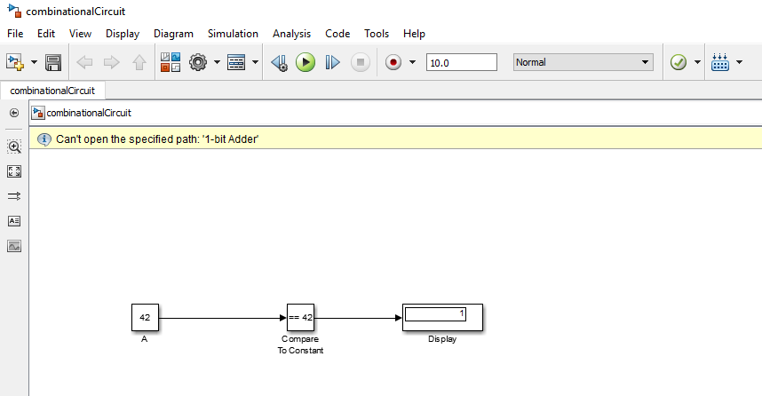

First, we set intput as an 8-bit int. then compare it with 42 (using comre to constant operator). Then it just works.